Assignment
____________________________________________________________________________________
Q-1: (5)What is keystroke level modeling? When and how would you use keystroke level modeling in the user interface design process? Provide an example illustrating the use of keystroke level modeling.
Q-2: (5)Consider the following statement: In order to improve an interface design, it is necessary to consult with the primary users of the system. Is this statement true or false? Explain your answer.
Q-3:(5)In the context of user interface design, what is meant by the learnability of a software system?
What is meant by the effectiveness of a software system?

Q-4:(5)Human memory places important limitations on how users interact with computers. Errors and mistakes are often attributed to human memory.
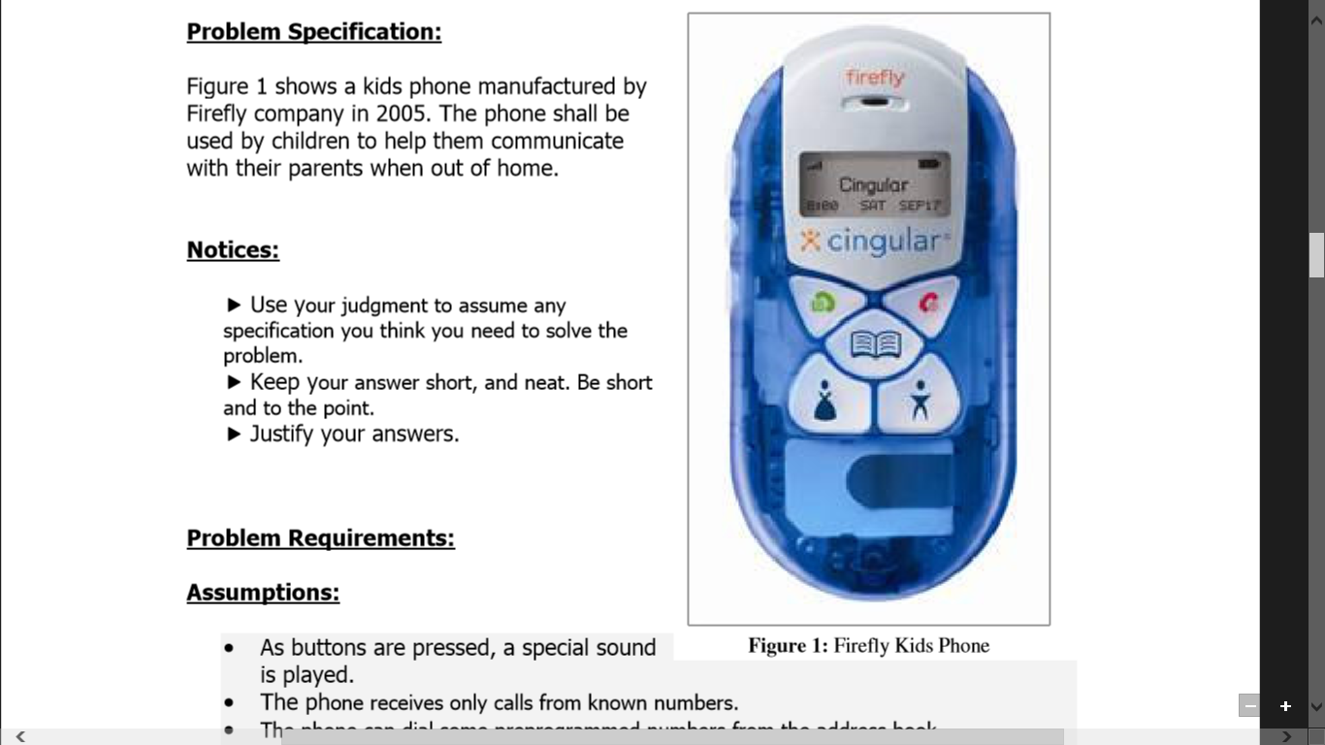
- Briefly outline the main components of human memory as described by information processing models.
Figure Q3
- In this context of human memory limitations and human computer interaction, describe what is meant by “CHUNKING”.
Q-5:(10)Sketch an interface design for an alarm clock. You must be able to set the current time, set the alarm time, turn the alarm on or off, and snooze (temporarily turn an active alarm oto rest a few more minutes). [There are NO other functions or features.]
In point form, explain the four most important or interesting features of your design. For each feature, list a design principle (or user need), then explain how the feature implements the principle
Q-6:(10)Figure Q-3 shows a kids phone manufactured by Firefly Company in 2005. The phone shall be used by children to help them communicate with their parents when out of home.
Given Information:• As buttons are pressed, a special sound is played. • The phone receives only calls from known numbers. • The phone can dial some preprogrammed numbers from the address book. • The

phone vibrates and is making a sound when someone is calling. Also it says so on the screen.
- Which age group do you think this phone targets?
- How do you think it is used? Do you think it is easy for children to use?
- What design, interaction, cognition principles (out of Visibility, Feedback, Recognition, Recall, Retain-ability, Metaphor, Consistency, Constraints, etc.) did its designers take into account when designing it? Explain your choices.
- Do you have any suggestions to improve the usability as well as the functionality of this phone?

Q-7:(20)As a GUI Design expert you have been asked to design the user interface for a new mobileapp which monitors and records in real time exercise activities such as walking,running and cycling.
- In this context:Explain usability evaluation. Also discuss briefly at least two usability evaluation methods that you would prefer to use in this case.(5)
- Define perceived ease of use and perceived usefulness in terms of interface design. Explain both with the help of this case.(5)
- How much important fits law will be in case of designing this interface for Elderly people? (5)
- Compare the interfaces below. Which one do you think is better? Why?(5)
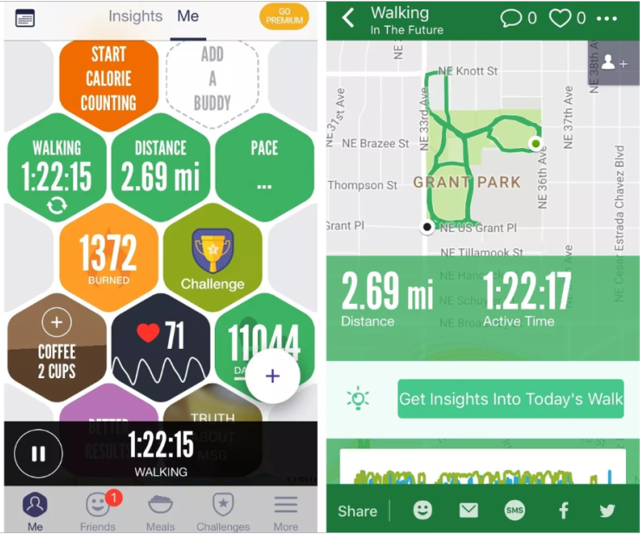 | 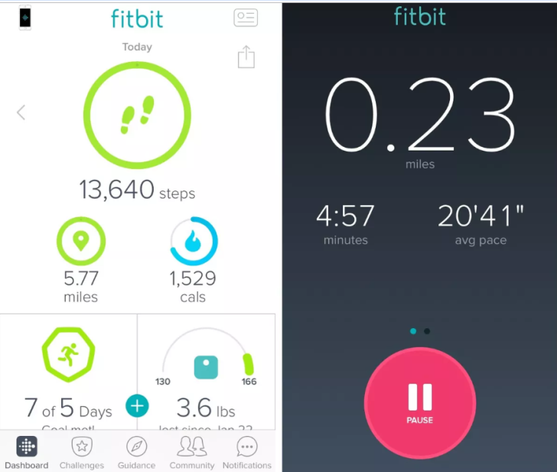
Fig Q7.1 | Fig Q7.2

Q-8:(10)Giving examples, explain:
- Double Duty
- Bimodal Perception
- Space Perception

